Low-Level Design (LLD) — Part Replaced Module
Attribute | Value
Module | Part Replaced (System Config Master)
Menu path | SYSTEM CONFIGURATION → Part Replaced
Landing page | part_replaced.php
Application | Complaint / Dealer Portal
Stack (target) | Core PHP + MySQL (PDO)
Stack (current repo) | Core PHP + PostgreSQL via PDO
Document version | 1.0
Access | System Admin only (role id 6) — no RBAC module slug
Architecture | Shared SCM stack ($scmType = 'part_replaced')

â”€â”€â”€â”€â”€â”€â”€â”€â”€â”€â”€â”€â”€â”€â”€â”€â”€â”€â”€â”€â”€â”€â”€â”€â”€â”€â”€â”€â”€â”€â”€â”€

1. Module Overview

1.1 Purpose
System Administrators maintain Part Replaced options in part_replaced_masters for Service Log Capture (and nested Service Log modals on Installed Base / Complaint). The module is a thin SCM wrapper sharing system_config_master_* pages, helpers, APIs, and JS. Consumers store the selected name string (not an FK id). Typical values include Yes / No (placeholder: e.g. Yes).

1.2 Scope
In scope | Out of scope
List / Add / Edit / Details / Soft-delete | Spare Parts Capture (does not use this master)
Active / Inactive status | Assigned Complaint visit free-text part_replaced field
Case-insensitive name uniqueness | Hard delete
Create abuse / rate-limit guard | Cascading rename/delete to service_logs
Active names for Service Log Select2 | Other SCM types

1.3 High-level architecture
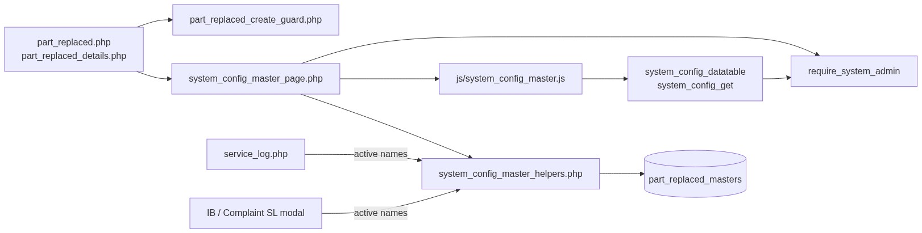
Figure 1 — High-level architecture
â”€â”€â”€â”€â”€â”€â”€â”€â”€â”€â”€â”€â”€â”€â”€â”€â”€â”€â”€â”€â”€â”€â”€â”€â”€â”€â”€â”€â”€â”€â”€â”€

2. Functional Requirements
ID | Requirement | Priority
FR-01 | System Admin can open Part Replaced list (DataTables) | Must
FR-02 | Create option with name and status | Must
FR-03 | Edit via inline slide-down form | Must
FR-04 | Soft-delete; hide from list | Must
FR-05 | Unique name among non-deleted (case/trim-insensitive) | Must
FR-06 | Filter / search list; status active/inactive | Should
FR-07 | View read-only details + audit fields | Should
FR-08 | Throttle / rate-limit create requests | Should
FR-09 | Client validate.js for name + status | Should
FR-10 | Expose active names to Service Log (and nested SL modals) | Must

â”€â”€â”€â”€â”€â”€â”€â”€â”€â”€â”€â”€â”€â”€â”€â”€â”€â”€â”€â”€â”€â”€â”€â”€â”€â”€â”€â”€â”€â”€â”€â”€

3. User Roles & Permissions

3.1 RBAC module slug
None. Part Replaced administration is gated by System Admin (SYSTEM_ADMIN_ROLE = 6), not a permission slug.

3.2 Permission matrix
Capability | Gate
All Part Replaced admin pages | require_system_admin($obconn) (via SCM page)
SCM APIs with type=part_replaced | admin_api_require_system_admin
Denied | Access denied. System Admin privileges required.

Pages (part_replaced.php, part_replaced_details.php, delete_part_replaced.php) are in rbac_admin_pages() and skip module RBAC; System Admin check is authoritative.

3.3 Page / API mapping
Resource | Gate
part_replaced.php | System Admin
part_replaced_details.php | System Admin
delete_part_replaced.php | System Admin
api/system_config_datatable.php?type=part_replaced | System Admin API
api/system_config_get.php?type=part_replaced | System Admin API

3.4 Consumer access
Service Log users need Service Log module permissions (separate). They only see active, non-deleted names via scm_get_active_names('part_replaced') / service_log_part_replaced_options().
â”€â”€â”€â”€â”€â”€â”€â”€â”€â”€â”€â”€â”€â”€â”€â”€â”€â”€â”€â”€â”€â”€â”€â”€â”€â”€â”€â”€â”€â”€â”€â”€

4. Business Rules
ID | Rule
BR-01 | Soft-deleted rows excluded from list, get, uniqueness, and SL options.
BR-02 | Name unique among non-deleted: LOWER(TRIM(name)); edit excludes self.
BR-03 | Soft-deleted names may be reused on create (partial unique index).
BR-04 | Status must be active or inactive.
BR-05 | Inactive names stay in admin list but are not offered in Service Log.
BR-06 | Soft-delete / rename does not update existing service_logs.part_replaced values.
BR-07 | No “in use” check before soft-delete.
BR-08 | Create-only abuse guard: max 1/request; min 3s interval; max 20 creates / 15 min.
BR-09 | Edit requires existing non-deleted row.
BR-10 | created_by = current_username() on insert; created_at / updated_at timestamps.
BR-11 | Details/delete URL ids are base64_encode((string) id).
BR-12 | Create/update stay on page (no PRG). Delete redirects to list with session flash.
BR-13 | Service Log stores the name string, not part_replaced_masters.id.
BR-14 | SCM type key is part_replaced; table part_replaced_masters; submit key submit_part_replaced.
BR-15 | Master name max 100; service_logs.part_replaced is VARCHAR(10) — keep option names ≤ 10 for safe storage.
BR-16 | When Part Replaced is Yes (service_log_part_replaced_is_yes), Service Log requires related part / machine entries (consumer rule).
BR-17 | Assigned Complaint service-update free-text part_replaced is not this SCM master.

â”€â”€â”€â”€â”€â”€â”€â”€â”€â”€â”€â”€â”€â”€â”€â”€â”€â”€â”€â”€â”€â”€â”€â”€â”€â”€â”€â”€â”€â”€â”€â”€

5. Database Design

5.1 ER diagram
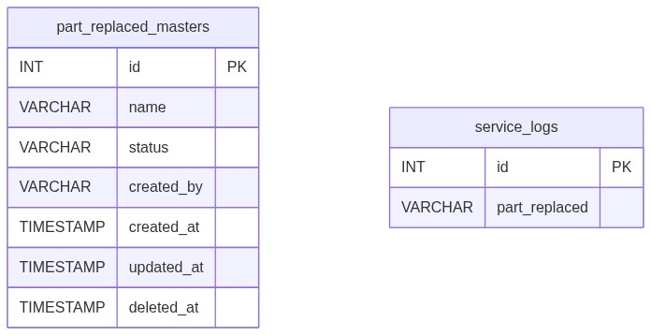
Figure 2 — Entity relationship diagram
Logical link (name string, not FK):
Figure 3 — Denormalized name link to Service Log

5.2 Table: part_replaced_masters
Column | MySQL type | Notes
id | INT UNSIGNED AUTO_INCREMENT | PK
name | VARCHAR(100) | Required; unique among non-deleted
status | VARCHAR(20) | active / inactive; default active
created_by | VARCHAR(100) | Creator username
created_at | TIMESTAMP | Insert
updated_at | TIMESTAMP NULL | Update / soft-delete
deleted_at | TIMESTAMP NULL | Soft-delete

Indexes (current repo): PK on id; partial unique on lower(trim(name)) WHERE deleted_at IS NULL; index on deleted_at.

5.3 Related tables
Table | Column | Role
service_logs | part_replaced VARCHAR(10) | Primary SCM consumer
complaint_service_updates | part_replaced (text) | Not SCM — free-text visit update

5.4 Reference / lookup sources
Source | Usage
scm_registry()['part_replaced'] | Labels, pages, table, submit key
rbac_status_options() | Status <select>
scm_get_active_names('part_replaced') | SL dropdown
service_log_part_replaced_options() | Consumer wrapper
service_log_part_replaced_is_yes() | Yes-branch gating

â”€â”€â”€â”€â”€â”€â”€â”€â”€â”€â”€â”€â”€â”€â”€â”€â”€â”€â”€â”€â”€â”€â”€â”€â”€â”€â”€â”€â”€â”€â”€â”€

6. API / Backend Design

6.1 Page endpoints
Endpoint | Method | Auth | Description
part_replaced.php | GET | System Admin | List + Add/Edit panel
part_replaced.php | POST submit_part_replaced | System Admin | Create or update
part_replaced_details.php?id= | GET | System Admin | Read-only details
delete_part_replaced.php?id= | GET | System Admin | Soft-delete

Wrappers set $scmType = 'part_replaced' and include shared SCM templates.

6.2 JSON APIs

POST api/system_config_datatable.php
Body/query includes type=part_replaced. Server-side DataTables over part_replaced_masters where deleted_at IS NULL.
{
"draw": 1,
"recordsTotal": 10,
"recordsFiltered": 2,
"data": [{ "id": "#1", "name": "...", "status": "...", "actions": "<html>" }]
}

GET api/system_config_get.php?type=part_replaced&id=
Returns row for edit form population. System Admin API gated.

6.3 Supporting lookup APIs
N/A for admin UI. Service Log / IB / Complaint SL modals load active names server-side into Select2 options.

6.4 Core PHP responsibilities
File | Role
part_replaced.php | Create-guard hook + $scmType wrapper
includes/system_config_master_page.php | Shared list/form POST handler
includes/system_config_master_details_page.php | Shared details
includes/system_config_master_delete.php | Shared soft-delete
includes/system_config_master_helpers.php | Registry, validate, CRUD, options
includes/module_create_guards/part_replaced_create_guard.php | Create throttle / rate limit
includes/admin_access_helpers.php | System Admin gate

â”€â”€â”€â”€â”€â”€â”€â”€â”€â”€â”€â”€â”€â”€â”€â”€â”€â”€â”€â”€â”€â”€â”€â”€â”€â”€â”€â”€â”€â”€â”€â”€

7. Validation Rules

7.1 Server-side (scm_validate + uniqueness + create guard)
Field / rule | Message
Name empty | Part Replaced name is required.
Name > 100 | Part Replaced name cannot exceed 100 characters.
Status missing/invalid | Status is required.
Duplicate name | Part Replaced name already exists. Please choose a different name.
Missing edit target | Part Replaced not found or already deleted.
Create throttle | Please wait a few seconds before creating another record.
Rate limit | Create rate limit exceeded. You may create up to 20 records every 15 minutes...
Bulk payload | Too many records in a single request. A maximum of 1 record(s)...

Service Log consumer: Part Replaced is required. / Invalid Part Replaced selection.
Yes-branch: At least one Machine Model / Part entry is required when Part Replaced is Yes.

7.2 Client-side (js/system_config_master.js)
â€¢ validate.js: Name required + max 100; Status required (generic wording)
â€¢ Edit load failure: Failed to load record details.
â€¢ Success alert fades after 3s
â€¢ Status is native <select> (no Select2 on master)
â”€â”€â”€â”€â”€â”€â”€â”€â”€â”€â”€â”€â”€â”€â”€â”€â”€â”€â”€â”€â”€â”€â”€â”€â”€â”€â”€â”€â”€â”€â”€â”€

8. UI Screen Specifications

8.1 Listing — part_replaced.php
Element | Spec
Subtitle | Manage part replaced options for service logs.
Placeholder | e.g. Yes
CTA | Add Part Replaced / Cancel (#scmFormCard)
Grid | #scmTable — ID, Name, Status, Created At, Action
List title | Part Replaced Options List
Actions | View / Edit / Delete (confirm('Delete this record?'))
Icon | bi-tools

8.2 Form panel
Fields: Name*, Status* (active / inactive).
Hidden: record_id, submit_part_replaced, SCM type wiring via scm_page_js_config.

8.3 Details — part_replaced_details.php
Name, status badge, created by, created/updated timestamps (shared record-details layout).

8.4 Modals / Select2
â€¢ No CRUD modals on master.
â€¢ Admin: native status select — no Select2.
â€¢ Consumers: Select2 on #serviceLogPartReplacedSelect, #ibServiceLogPartReplacedSelect.
â”€â”€â”€â”€â”€â”€â”€â”€â”€â”€â”€â”€â”€â”€â”€â”€â”€â”€â”€â”€â”€â”€â”€â”€â”€â”€â”€â”€â”€â”€â”€â”€

9. Database Flow

9.1 Create
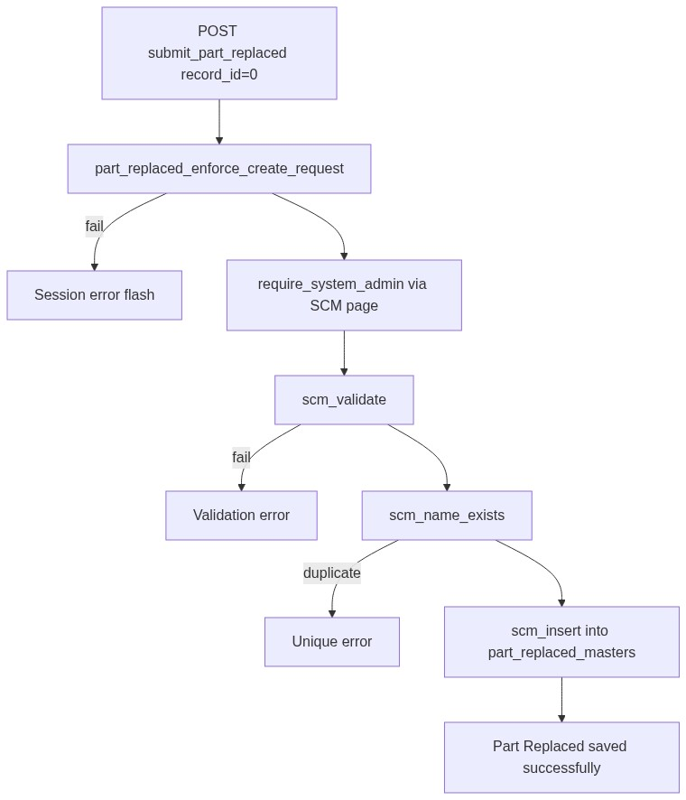
Figure 4 — Create database flow

9.2 Soft-delete
UPDATE part_replaced_masters
SET deleted_at = CURRENT_TIMESTAMP,
updated_at = CURRENT_TIMESTAMP
WHERE id = :id
AND deleted_at IS NULL;

9.3 Active options for Service Log
SELECT name
FROM part_replaced_masters
WHERE deleted_at IS NULL
AND status = 'active'
ORDER BY created_at ASC, id ASC;
â”€â”€â”€â”€â”€â”€â”€â”€â”€â”€â”€â”€â”€â”€â”€â”€â”€â”€â”€â”€â”€â”€â”€â”€â”€â”€â”€â”€â”€â”€â”€â”€

10. Sequence Diagram

10.1 Create part replaced option
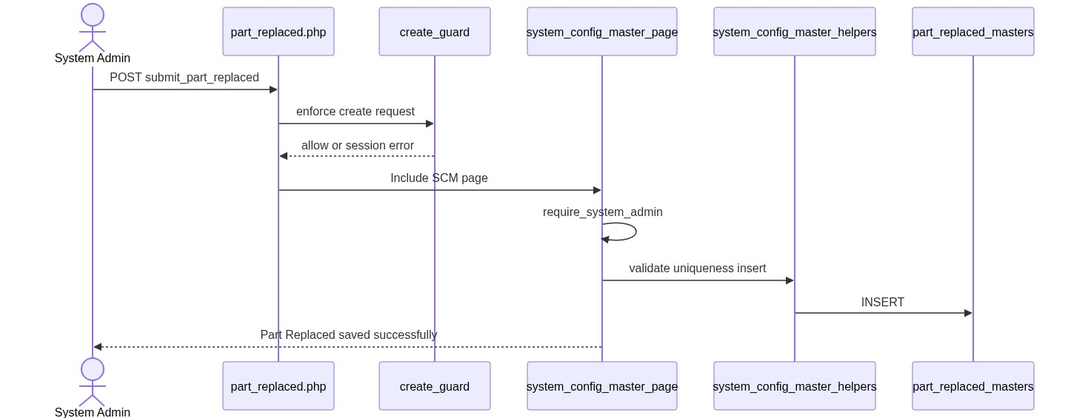
Figure 5 — Sequence: Create part replaced option

10.2 Soft-delete and Service Log impact
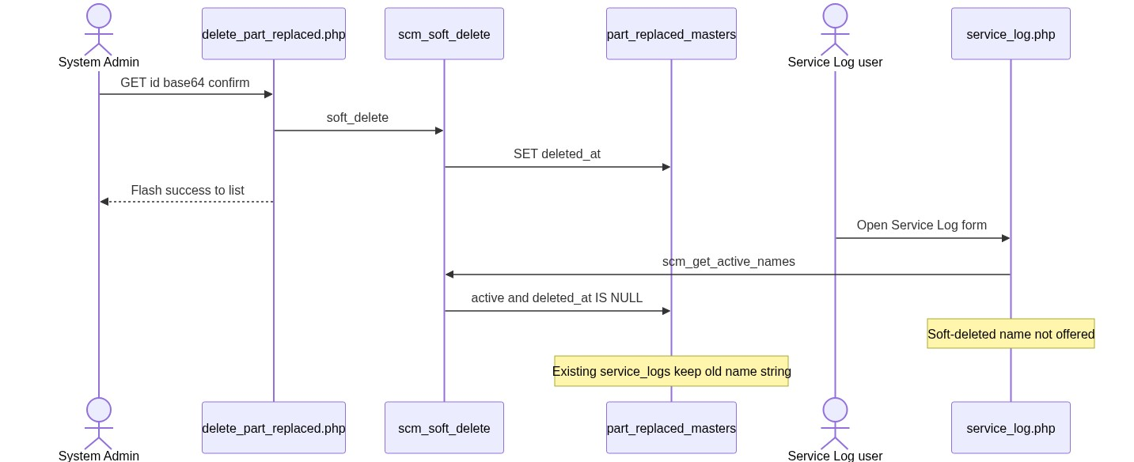
Figure 6 — Sequence: Soft-delete and Service Log impact
â”€â”€â”€â”€â”€â”€â”€â”€â”€â”€â”€â”€â”€â”€â”€â”€â”€â”€â”€â”€â”€â”€â”€â”€â”€â”€â”€â”€â”€â”€â”€â”€

11. Activity Diagram
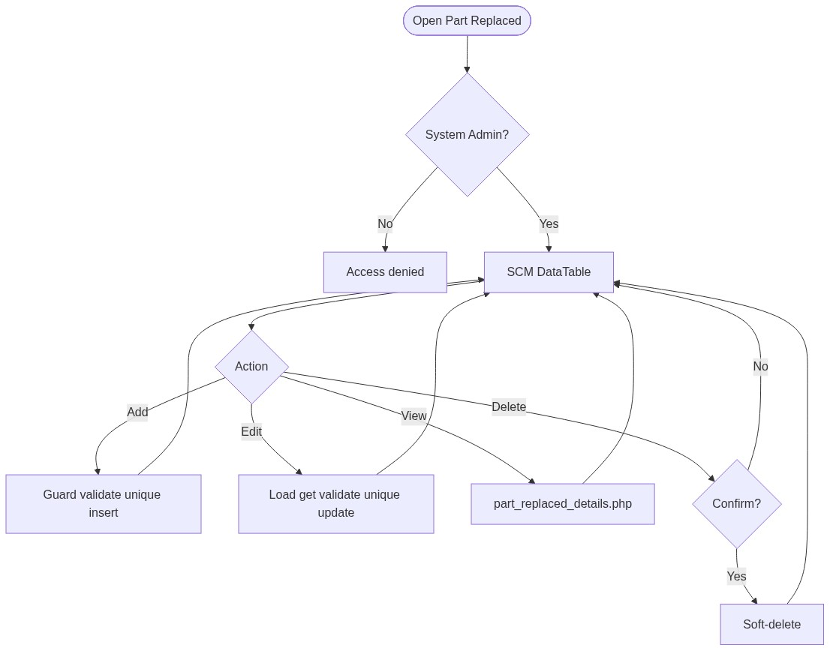
Figure 7 — Activity diagram
â”€â”€â”€â”€â”€â”€â”€â”€â”€â”€â”€â”€â”€â”€â”€â”€â”€â”€â”€â”€â”€â”€â”€â”€â”€â”€â”€â”€â”€â”€â”€â”€

12. Class / Module Diagram
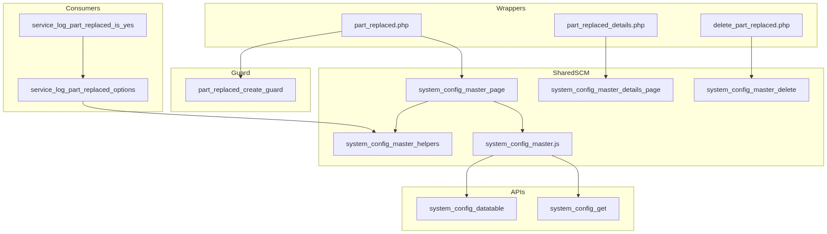
Figure 8 — Class / module diagram

12.1 Key functions
Function | Role
scm_registry / scm_config | Type → table/pages/labels
scm_safe_table | Whitelist table name
scm_from_post / scm_validate | Parse + validate
scm_name_exists | Uniqueness
scm_insert / scm_update / scm_soft_delete | Persist
scm_get_by_id / scm_get_active_names / scm_option_exists | Reads
scm_entry_actions / scm_page_js_config | UI/API wiring
part_replaced_enforce_create_request | Create abuse guard
service_log_part_replaced_options | SL active-name options
service_log_part_replaced_is_yes | Yes-branch consumer rule
require_system_admin | Access gate

â”€â”€â”€â”€â”€â”€â”€â”€â”€â”€â”€â”€â”€â”€â”€â”€â”€â”€â”€â”€â”€â”€â”€â”€â”€â”€â”€â”€â”€â”€â”€â”€

13. Folder Structure
ComplaintManagement/
├── part_replaced.php
├── part_replaced_details.php
├── delete_part_replaced.php
├── api/
│ ├── system_config_datatable.php
│ └── system_config_get.php
├── includes/
│ ├── system_config_master_helpers.php
│ ├── system_config_master_page.php
│ ├── system_config_master_details_page.php
│ ├── system_config_master_delete.php
│ ├── admin_access_helpers.php
│ ├── admin_api_guard.php
│ └── module_create_guards/
│ └── part_replaced_create_guard.php
├── js/
│ └── system_config_master.js
├── storage/
│ └── request_abuse/part_replaced/
└── docs/
└── LLD_Part_Replaced_Module.md
â”€â”€â”€â”€â”€â”€â”€â”€â”€â”€â”€â”€â”€â”€â”€â”€â”€â”€â”€â”€â”€â”€â”€â”€â”€â”€â”€â”€â”€â”€â”€â”€

14. Error Handling
Layer | Pattern
Create guard fail | $_SESSION['error_message']; POST submit unset
Page POST | Inline / session success or error via SCM page
Delete | Session flash → part_replaced.php
Details invalid | die('Invalid record.') / die('Part Replaced not found.')
APIs | JSON + HTTP 403/404
Create guard log | storage/request_abuse/part_replaced/

14.1 Common messages
Message | When
Part Replaced saved successfully. | Create
Part Replaced updated successfully. | Update
Part Replaced deleted successfully. | Soft-delete
Failed to save part replaced. / Failed to update... / Failed to delete... | Persist fail
Part Replaced not found or already deleted. | Missing target
Part Replaced name already exists... | Unique violation
Invalid record. | Bad delete id
Access denied. System Admin privileges required. | Non-admin

â”€â”€â”€â”€â”€â”€â”€â”€â”€â”€â”€â”€â”€â”€â”€â”€â”€â”€â”€â”€â”€â”€â”€â”€â”€â”€â”€â”€â”€â”€â”€â”€

15. Security Considerations
Area | Control
Authorization | System Admin hard-gate on SCM pages + APIs
Soft-delete | Excluded from active queries and SL options
Create abuse | Throttle, rate limit, payload size, monitor log
Table safety | scm_safe_table whitelist for datatable SQL
DB uniqueness | Partial unique index on lower(trim(name)) among non-deleted
CSRF | Not implemented on POST or GET delete
Delete method | GET soft-delete — CSRF-friendly; confirm only
PRG | Not used on create/update
Guard order gap | Create guard runs before require_system_admin → non-admins may write throttle/abuse files
Option exists gap | scm_option_exists ignores status → inactive name can pass SL server check if forced in POST
Length mismatch | Master VARCHAR(100) vs service_logs.part_replaced VARCHAR(10)
Denormalized names | Rename/delete orphans historical SL values
Confusion risk | Assigned Complaint free-text part_replaced is a different field

â”€â”€â”€â”€â”€â”€â”€â”€â”€â”€â”€â”€â”€â”€â”€â”€â”€â”€â”€â”€â”€â”€â”€â”€â”€â”€â”€â”€â”€â”€â”€â”€

16. Audit Logs

16.1 Built-in field-level audit
Field | Behavior
created_by / created_at | On create
updated_at | On update / soft-delete
deleted_at | Soft-delete
Dedicated audit table | Not implemented
Create abuse log | storage/request_abuse/part_replaced/abuse_monitor.log

â”€â”€â”€â”€â”€â”€â”€â”€â”€â”€â”€â”€â”€â”€â”€â”€â”€â”€â”€â”€â”€â”€â”€â”€â”€â”€â”€â”€â”€â”€â”€â”€

17. Test Cases

17.1 Functional
ID | Scenario | Expected
TC-01 | Non-admin opens Part Replaced | Denied
TC-02 | Create with empty name | Validation error
TC-03 | Create duplicate name (different case) | Rejected (app + DB unique)
TC-04 | Soft-delete then recreate same name | Allowed
TC-05 | Set status inactive | In admin list; not in SL Select2
TC-06 | Soft-delete name used on SL rows | Rows keep old string; dropdown omits it
TC-07 | Edit via pencil | Form filled from system_config_get
TC-08 | Delete confirmed | Soft-deleted; flash success
TC-09 | Create twice within 3 seconds | Throttle error
TC-10 | Create >20 in 15 minutes | Rate-limit error
TC-11 | Service Log submit without Part Replaced | Part Replaced is required.
TC-12 | Service Log submit unknown name | Invalid Part Replaced selection.
TC-13 | Part Replaced = Yes without part rows | Yes-branch validation error
TC-14 | Name longer than 10 chars | May save on master but truncate/fail risk on SL
TC-15 | Datatable type=part_replaced as admin | Rows from part_replaced_masters
TC-16 | Assigned visit free-text part_replaced | Saves without SCM option check

â”€â”€â”€â”€â”€â”€â”€â”€â”€â”€â”€â”€â”€â”€â”€â”€â”€â”€â”€â”€â”€â”€â”€â”€â”€â”€â”€â”€â”€â”€â”€â”€

18. Assumptions & Dependencies

18.1 Assumptions
1. Role id 6 is System Admin.
2. Soft-delete is the only remove mechanism.
3. Service Log (including IB / Complaint SL modals) is the primary SCM consumer.
4. Operational practice keeps option names ≤ 10 characters to match service_logs.part_replaced.
5. Name string denormalization on SL is intentional for historical display.
6. Shared SCM stack remains the implementation vehicle.
7. Document target stack Core PHP + MySQL; repo runs PostgreSQL.
8. Create-guard storage under storage/request_abuse/part_replaced/ is writable.
9. Typical catalog values are short labels such as Yes / No.

18.2 Dependencies
Dependency | Purpose
SCM shared pages/helpers/JS/APIs | CRUD UI and persistence
admin_access_helpers / admin_api_guard | System Admin gate
rbac_helpers | Status options / validation / badges
Create-guard storage | Throttle state + abuse log
jQuery + DataTables + validate.js | List / form UX
Service Log module | Consumer of active names + Yes-branch rules

â”€â”€â”€â”€â”€â”€â”€â”€â”€â”€â”€â”€â”€â”€â”€â”€â”€â”€â”€â”€â”€â”€â”€â”€â”€â”€â”€â”€â”€â”€â”€â”€

Appendix A — Success flashes
Event | Message
Create | Part Replaced saved successfully.
Update | Part Replaced updated successfully.
Delete | Part Replaced deleted successfully.

â”€â”€â”€â”€â”€â”€â”€â”€â”€â”€â”€â”€â”€â”€â”€â”€â”€â”€â”€â”€â”€â”€â”€â”€â”€â”€â”€â”€â”€â”€â”€â”€

Appendix B — Select2 control map
Screen | Control | Select2?
Admin status select | Native <select> | No
Service Log #serviceLogPartReplacedSelect | Select2 | Yes (consumer)
IB / Complaint SL modal #ibServiceLogPartReplacedSelect | Select2 | Yes (consumer)

â”€â”€â”€â”€â”€â”€â”€â”€â”€â”€â”€â”€â”€â”€â”€â”€â”€â”€â”€â”€â”€â”€â”€â”€â”€â”€â”€â”€â”€â”€â”€â”€

Appendix C — SCM registry entry
Key | Value
Type | part_replaced
Table | part_replaced_masters
Label | Part Replaced
Plural | Part Replaced Options
Page | part_replaced.php
Submit key | submit_part_replaced
Icon | bi-tools

â”€â”€â”€â”€â”€â”€â”€â”€â”€â”€â”€â”€â”€â”€â”€â”€â”€â”€â”€â”€â”€â”€â”€â”€â”€â”€â”€â”€â”€â”€â”€â”€

Appendix D — Create guard limits
Limit | Value
Max records per request | 1
Min interval between creates | 3 seconds
Max creates per window | 20
Window | 15 minutes

â”€â”€â”€â”€â”€â”€â”€â”€â”€â”€â”€â”€â”€â”€â”€â”€â”€â”€â”€â”€â”€â”€â”€â”€â”€â”€â”€â”€â”€â”€â”€â”€

Appendix E — Status vs consumer visibility
Value | Admin list | Service Log options
active | Yes | Yes
inactive | Yes | No
Soft-deleted | No | No

â”€â”€â”€â”€â”€â”€â”€â”€â”€â”€â”€â”€â”€â”€â”€â”€â”€â”€â”€â”€â”€â”€â”€â”€â”€â”€â”€â”€â”€â”€â”€â”€

Appendix F — Consumer column map
Module | Column | SCM-gated? | Max length
Service Log | service_logs.part_replaced | Yes | 10
Master | part_replaced_masters.name | N/A | 100
Assigned visit update | complaint_service_updates.part_replaced | No (free text) | text

â”€â”€â”€â”€â”€â”€â”€â”€â”€â”€â”€â”€â”€â”€â”€â”€â”€â”€â”€â”€â”€â”€â”€â”€â”€â”€â”€â”€â”€â”€â”€â”€

Appendix G — Yes-branch note
service_log_part_replaced_is_yes($value) treats trimmed case-insensitive Yes as true. When true, Service Log requires at least one Machine Model / Part entry (and related running hours / feedback paths as implemented in Service Log module).
â”€â”€â”€â”€â”€â”€â”€â”€â”€â”€â”€â”€â”€â”€â”€â”€â”€â”€â”€â”€â”€â”€â”€â”€â”€â”€â”€â”€â”€â”€â”€â”€
End of LLD — Part Replaced Module

